pXRF analysis

Uine Kailamäki

04/01/2021

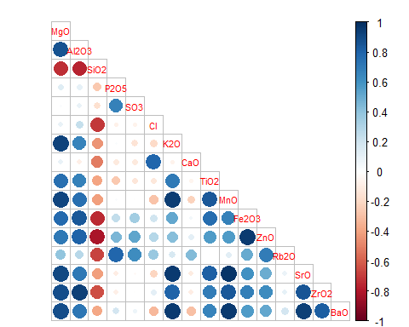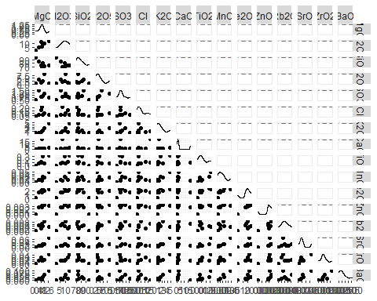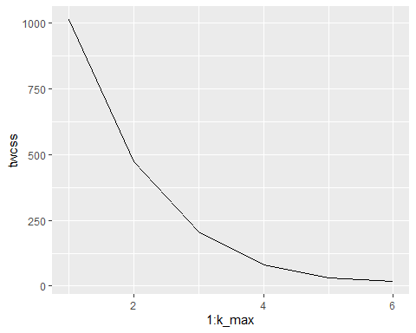

## Importance of components:  
## PC1 PC2 PC3 PC4 PC5 PC6 PC7  
## Standard deviation 11.0686 5.9563 3.02542 1.29136 0.48845 0.20560 5.819e-16  
## Proportion of Variance 0.7245 0.2098 0.05413 0.00986 0.00141 0.00025 0.000e+00  
## Cumulative Proportion 0.7245 0.9344 0.98848 0.99834 0.99975 1.00000 1.000e+00

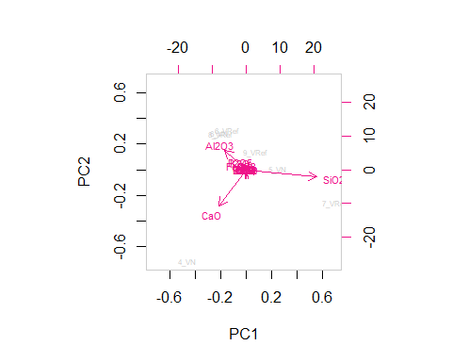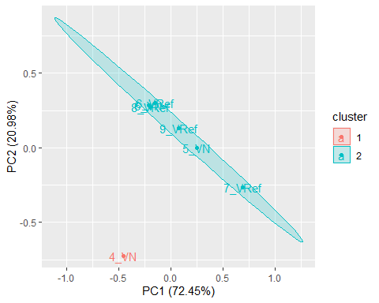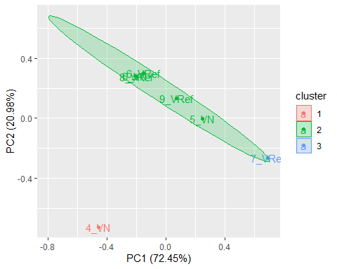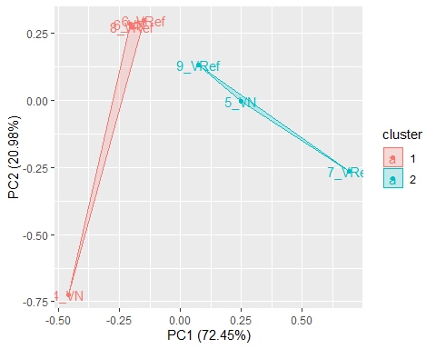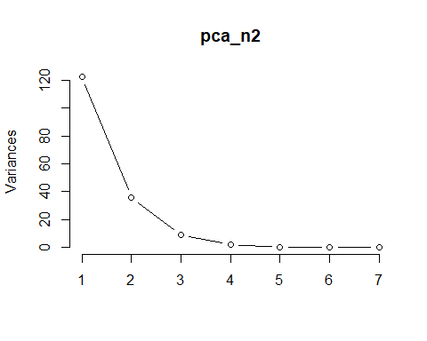

## [1] 0.6765362

